Active Shooter Response: What You Can Do
Resources – Supplemental to FEMA’s IS – 907 (Online Course – see below link)
Michael Melton, mike.melton@constantassociates.com (Updated: May 6, 2022)
- FEMA’s IS–907 course (https://training.fema.gov/is/courseoverview.aspx?code=IS-907)
  - FEMA’s online course for Active Shooter preparedness and response is one of FEMA’s Independent Study (IS) offerings, and the course takes approximately 80 minutes to complete

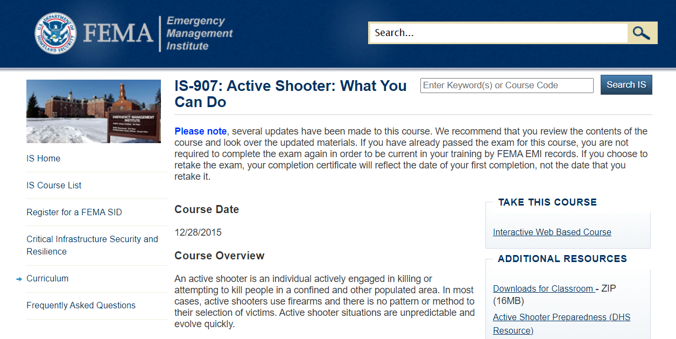

- Department of Homeland Security (http://www.dhs.gov/active-shooter-preparedness )

- “Active Shooter Awareness Guidance” –
  - California Governor’s Office of Emergency Services (Cal OES) publication from September 2016 http://www.nccpsafety.org/assets/files/library/Cal_OES_Active_Shooter_Awareness_Guidance.pdf
  - Active Shooter Planning and Response: Learn How To Survive a Shooting Event In a Healthcare Setting, 2017, Healthcare and Public Health Sector Coordinating Council

- Stop the Bleeding Initiative – All of the below links:
- https://www.dhs.gov/stopthebleed
- http://www.bleedingcontrol.org/
- https://www.domesticpreparedness.com/preparedness/one-mission-for-active-shooter-response-saving-lives/

- LASD – Excellent 10-min. video and links to more (http://www.activeshooter.lasd.org/ )

- Federal Bureau of Investigation – (https://www.fbi.gov )

Active Shooter Response Graphics
Michael Melton, mike.melton@constantassociates.com (Updated: May 6, 2022)
