Tool for Identification of Shelter-In-Place (or “Safer”) Room for Use to Hide during a Violent Attack

Facility Name: _______________________________ Room #: _________ Floor #: _________

Describe room’s location* within the facility on below line and enter demographic information in the table:
__________________________________________________________________________

Room’s Dimensions | Approximate Square Ft. | Number of Doors | Number of Windows | Potential Occupancy for Hiding / Shelter-In-Place

List: # of workforce members / Room’s day-to-day use(s), and / Primary contents, e.g., desks; cabinets; boxes:
#______ / ________________________________ / _____________________________

Checklist/Table of Room’s Characteristics Related to Hiding in a Violent Attack – “Yes” response is favorable

Primary Issue | Sub-Issue | Yes/No | Any Clarifying Information
Intrusion Resistant Door(s) | Sub-Assessment (Satisfactory?) |  | Sub-topic status based on 6 responses.
 | Door(s) is/are solidly constructed?
 | Door(s) has/have interior lock(s)?
 | Door(s) open/swing inward?
 | Door(s) is/are away from window/glass?
 | Door(s) has/have peep hole(s)?
 | Door offers potential direct exit to outside?
Intrusion Resistant Window(s) | Sub-Assessment (Satisfactory?) |  | Sub-topic status based on 5 responses.
 | No window to inside space? (None = Yes)
 | - Any internal window has blinds?
 | Windows to outside are secure?
 | Windows to outside have blinds?
 | Windows to outside could be used to exit?
Intrusion Resistant Walls | Sub-Assessment (Satisfactory?) |  | Sub-topic status based on 2 responses.
 | Walls are drywall or plaster?
 | Walls are masonry or concrete?
Room is directly accessible | Sub-Assessment (Satisfactory?) |  | Sub-topic status based on 2 responses.
 | Clear pathway leads to door(s)?
 | Path is wheelchair accessible?
Room has access to controls | Sub-Assessment (Satisfactory?) |  | Sub-topic status based on 3 responses.
 | Landline telephone?
 | Intercom?
 | Room lights?
Room has access to OTHER | Sub-Assessment (Bonus Items?) |  | Sub-topic status based on 5 responses.
 | Secondary hiding spaces or cover?
 | Capability to barricade the door(s)?
 | Exit door to area other than entry?
 | Capability to block the window(s)?
 | Item(s) for improvised weapon(s)?

Based on above assessment, is this room deemed suitable for designation as a “Safer” room? _________

Name(s) of person(s) who conducted this inspection and the date of the assessment:

Name(s): _____________________________ / ___________________________ Date: ____________

* A diagram of the room’s location may be included. Is a diagram being provided? (Yes/No) _________

(Tool was provided by Michael Melton, mike.melton@constantassociates.com )

Instructions for “Safer” Room Identification for Use to Shelter-In-Place during a Violent Attack Event

Prepared by Mike Melton, 05-05-22, mike.melton@constantassociates.com

REFERENCE:
“Tool for Identification of Shelter-In-Place (or “Safer”) Room for Use to Hide during a Violent Attack”

FORMAT OF THE BELOW INSTRUCTIONAL CONTENT:
- The format of the instructional content, which is related to the use of the to above referenced tool, is:
  - First the source of the provided except is identified
  - Next, the exact information, which was identified in the source as most relevant, is provided
  - Finally, various means were used to emphasize key points, including yellow highlight, bold, etc.
- While specific word content of each except is unchanged from the source, understanding is influenced:
  - As a result of the various means of emphasis that have been added to the copied text
  - By the addition of several “NOTES:”, which are provided as italicized text

Source: Planning and Response to an Active Shooter: An Interagency Security Committee Policy and Best Practices Guide, page 7

- Evacuation, shelter-in-place, hide, and lockdown policies and procedures for individual offices and buildings.
  - Emergency escape procedures and route assignments (e.g., floor plans, safe areas), including where to evacuate and how to evacuate when the primary evacuation routes are unusable.
    - Plans should clearly explain shelter-in-place and lockdown procedures, including the differences between the two.
  - How to select effective “hide” locations.
    - Optimal locations have ballistic protection known as “cover” which include thick walls made of steel, cinder block, or brick and mortar; solid doors with locks; and areas with minimal glass and interior windows. These areas can be stocked with accessible first aid and emergency kits designed for hemorrhage control, communication devices, and telephones and/or duress alarms.
    - Designated “shelter-in-place” locations are often designed for natural hazards (earthquakes, tornadoes, etc.) and may not be ideal for active shooter incidents. Facilities and/or agencies should consider the development of safe rooms when selecting or renewing a leased facility or new construction. See below for a discussion of safe rooms.
  - Personnel involved in such planning should ensure all sheltering sites and evacuation routes are accessible for persons with disabilities.

Source: Planning and Response to an Active Shooter: An Interagency Security Committee Policy and Best Practices Guide, pages 21 – 22

7.2 Hide
If running is not a safe option, staff should be trained to hide in as safe a place as possible where the walls might be thicker and have fewer windows. Likewise, for occupants that cannot run, hiding may be the only option.

In addition, occupants should do the following:
- Lock the doors and/or barricade them with heavy furniture, if possible.
- Close and lock windows and close blinds or cover windows.
- Turn off lights.
- Silence all electronic devices.
- Remain silent.
- Look for other avenues of escape.
- Identify ad-hoc weapons.
- When safe to do so, use strategies to silently communicate with first responders, if possible (e.g., in rooms with exterior windows, make signs to silently signal law enforcement and emergency responders to indicate the status of the room’s occupants).
- Hide along the wall closest to the exit but out of view from the hallway (which would allow the best option for ambushing the shooter and for possible escape if the shooter enters or passes by the room).
- Remain in place until given an all clear by identifiable law enforcement.

Consider these additional actions:
- Identify a safe location on each floor before an incident occurs where occupants and visitors may safely barricade themselves during an event.
- Train people in how to lock down an area and secure the unit, including providing a checklist of instructions on the back of doors and by phones.
- Ensure emergency numbers are available at all phone locations.

Consider the following questions if developing a threat annex for the run, hide, fight scenario:
- Have shelter-in-place locations been identified?
- Is there a method to secure the access to these locations?
- Have employees rehearsed the movement to and positioning within these locations?
- How will communications be established with these locations?

Source: Incorporating Active Shooter Incident Planning Into Health Care Facility Emergency Operations Plans, pages 11-12

How to select effective shelter-in-place locations. Optimal locations have ballistic protection known as “cover,” which includes thick walls made of steel, cinder block, or brick and mortar; solid doors with locks; and areas with minimal glass and interior windows. These areas can be stocked with accessible first aid and emergency kits designed for hemorrhage control, communication devices, and telephones and/or duress alarms.

Providing safe rooms in health care settings.
Some facilities have opted to construct safe rooms. Such rooms are designated spaces where staff, patients, and even visitors can retreat to in the event of an immediate threat of danger. A designated safe room should be equipped with a duress button, telephone, reinforced, locking doors with peep-holes installed, and an external lock with key access. Safe rooms must provide physical and communication accessibility for people with disabilities.

Source: Safe Rooms and Shelters – Protecting People Against Terrorist Attacks, page i

These safe rooms will protect occupants from a variety of hazards, including debris impact, accidental or intentional explosive detonation, and the accidental or intentional release of a toxic substance into the air. Safe rooms may also be designed to protect individuals from assaults and attempted kidnapping, which requires design features to resist forced entry and ballistic impact. This covers a range of protective options, from low-cost expedient protection (what is commonly referred to as sheltering-in-place) to safe rooms ventilated and pressurized with air purified by ultra-high-efficiency filters.

NOTE: The referenced tool is to identify “Safer” rooms rather than above described “Safe” rooms.

Source: Safe Rooms and Shelters – Protecting People Against Terrorist Attacks, page ii

This guidance focuses on safe rooms as standby systems, ones that do not provide protection on a continuous basis.

An internal shelter is a specially designed and constructed room or area within or attached to a larger building that is structurally independent of the larger building and is able to withstand the range of natural and manmade hazards.

Source: Safe Rooms and Shelters – Protecting People Against Terrorist Attacks, page iv

This approach does not attempt to address a specific threat because there are too many possible scenarios to generalize a threat-specific approach; however, it does allow the user to determine the feasible options that may be evaluated on a case by case basis to determine a response to any postulated threat. For protection against assault and attempted kidnapping, a level of forced entry and ballistic resistance may be specified.

Source: Safe Rooms and Shelters – Protecting People Against Terrorist Attacks, page 1-22

Multi-use shelters. The ability to use a shelter for more than one purpose often makes a multi-use standalone or internal shelter appealing to a shelter owner or operator. Multi-use shelters also allow immediate return on investment for owners/operators; the shelter space is used for daily business when the shelter is not being used during a hazard event.

NOTE: The referenced tool is to identify “Safer” rooms - Also referred to as “multi-use shelter” or “shelter-in-place room” recommendations

Source: Safe Rooms and Shelters – Protecting People Against Terrorist Attacks, pages 1-23 through 1-25

In inspecting areas of existing buildings that are used as shelter areas, research has found that owners may overlook the safest area of a building, while the safety of a hallway or other shelter areas may be overestimated. Evaluating shelter areas in an existing building or determining the best areas for new ones is invaluable for saving lives when a disaster strikes.

The shelter location on the site and capacity should consider how many occupants work in the building, as well as how many non-occupants may take refuge in the nearest shelter available.

It should also determine if the location is easily accessible, contains the required square footage, and has good ingress and egress elements.

The shelter should be located such that all persons designated to take refuge may reach the shelter with minimal travel time.

Routes to the shelter should be easily accessible and well marked.

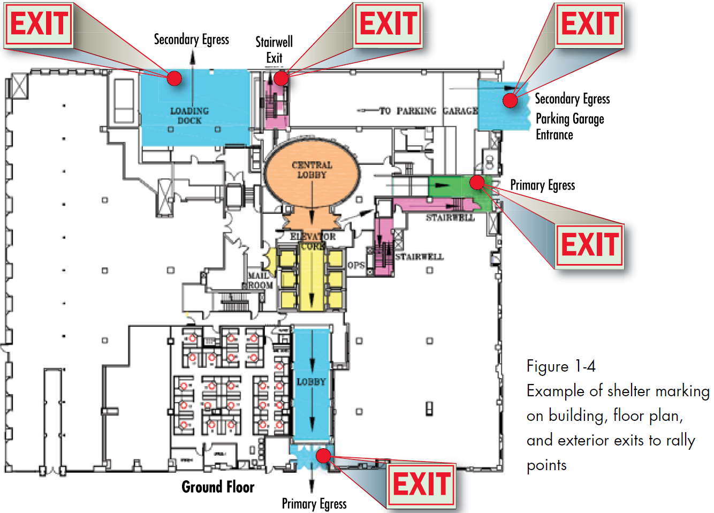

NOTE: While exits and routes are clearly marked on the provided sample diagram, the areas of any pre-identified shelter locations within the building were NOT marked in this EXAMPLE.

Source: Safe Rooms and Shelters – Protecting People Against Terrorist Attacks, page 1-27

Closets, bathrooms, and small storage rooms offer the advantage of having a function other than providing occasional storm protection. Typically, these rooms have only one door and no windows, which make them well-suited for conversion to a shelter. Bathrooms have the added advantage of a water supply and toilet.

Source: Safe Rooms and Shelters – Protecting People Against Terrorist Attacks, page 1-36

Travel time may be especially important when shelter users have disabilities that impair their mobility. Those with special needs may require assistance from others to reach the shelter; wheelchair users may require a particular route that accommodates the wheelchair.

Source: Safe Rooms and Shelters – Protecting People Against Terrorist Attacks, page 1-57

Safe Refuge Area (SRA). The SRA is located in the Warm Zone and used to assemble survivors and witnesses that are not injured and will require minimal medical attention and decontamination. Law enforcement and FBI agents can conduct interviews and gather evidence at the SRA.

NOTE: This description of a Safe Refuge Area is NOT the same as the pre-identified “Safer” Room, which is the primary focus of this document.

Source: Safe Rooms and Shelters – Protecting People Against Terrorist Attacks, page 2-17

2.3.4 Forced Entry and Ballistic Resistance
Ballistic-resistant design involves both the blocking of sightlines to conceal the occupants and the use of ballistic-resistant materials to minimize the effectiveness of the weapon.

Source: Safe Rooms and Shelters – Protecting People Against Terrorist Attacks, page 2-18

Forced entry resistance is measured in the time it takes for an aggressor to penetrate the enclosure using a variety of hand tools and weapons.

The different layers of defense create a succeeding number of security layers that are more difficult to penetrate, provide additional warning and response time, and allow building occupants to move into defensive positions or designated safe haven protection. The rated delay time for each component comprising a defense layer (walls, doors, windows, roofs, floors, ceilings, and utility openings) must be known in order to determine the effective delay time for the safe room. Conventional construction offers little resistance to most forced entry threat severity levels…

Source: K-12 School Security: A Guide for Preventing and Protecting Against Gun Violence, pages 18

Door Blockers (Discussion)
Door blockers are a relatively simple way to easily barricade a shooter from entering a doorway to classrooms, offices, auditoriums, hallways, etc. This may be a viable alternative for schools lacking doors that can be physically locked. There are many types/models to choose from, accounting for the type of doors in place, who will be using them, cost, installation, etc.
Cost: The purchase price of door blockers can vary but they are a relatively low cost item. Some door blockers must be physically installed which may increase the cost.
Maintenance: Door blockers should be regularly inspected and tested at least once annually to ensure operability.
Training and Accessibility: Most door blockers are simple and straightforward to use. Schools should consider providing a demonstration to faculty, staff, and/ or students to promote usability and effective deployment in the event of an active shooter. Door blockers should be stored in accessible locations.
  - First Responders: Door blockers will prevent anyone from accessing the room/area, not only the perpetrator. First responders may be able to defeat the door blocker but it will delay entry, scene clearing, provision of medical aid, etc. Schools should also discuss fire code compliance with first responder agencies.

Source: Active Shooter Planning and Response in a Healthcare Setting, page 45

Pre-planned Areas of Refuge
Pre-planned areas of refuge are a good concept if appropriately identified and disseminated among the employees of the healthcare facility, enabling them to bring that capability into their individual decision making cycle when responding to an active shooter. At the onset of an active shooter incident in a healthcare facility, tough decisions will need to be made by both attending medical staff and visiting family or friends. The medical staff may be caring for an immobile patient and feel a moral obligation to stay and protect that patient while family and friends simply feel that they can’t leave a loved one that is incapable of defending them self. In either case, this will potentially result in more victims for the shooter and ultimately, more fatalities. If facility security informs law enforcement areas of refuge are designated throughout the facility, it is incumbent upon law enforcement to acknowledge the plan and seek out those areas for familiarity.

