Tool to Support I.D. of Personal Action Options (Run, Hide & Fight) for Use during Violent Attack

Facility Name: _______________________________ Room/Cubicle #: _________ Floor #: _________

Describe room/cubicle’ s location within the facility* on below line and enter demographic data in the table:
______________________________________________________________________________________

What Is Your Space (Cubicle or Room)? | Cubicle/Room’s Dimensions | Approximate Square Feet | # of Doors/ Entrances | Entry(ies) Lockable? | # of Windows | Windows Covered?

List: # of workforce members / Space’s day-to-day use(s), and / Primary contents, e.g., desks; cabinets; boxes:
#______ / ________________________________________ / _________________________________________

Table that Supports I.D. of Your Personal Action Options (Run, Hide & Fight) for Use during Violent Attack

Run: | Brief Description of Pre-Identified Escape Paths*  (e.g., List 1st turn & your route to the destination) | List Destination & Issues or Key Concerns  (e.g., South stairwell, but 7 flights to exit)
Most Likely
Next Most Likely
Other
Option
NOTE: If your space is a Room with a door, then use the Shelter In Place Checklist as part of your Hide assessment.
Hide: | Brief List & Description of Hiding Options  (e.g., Under desk; or corner & behind file cabinet) | List Hiding Options Near Your Space  (e.g., Storage closet across aisle; Rm 719)
Most Likely
Next Most Likely
Other Option
Fight: | Item for Potential Use as an Improvised Weapon  (e.g., Scissors; Metal stapler; 3-hole punch; Etc.) | Item for Potential Thrown Distraction  (e.g., Plastic stapler; Chair; Book; Etc.)
Most Likely
Next Most Likely
Other Option

Name(s) of person(s) who conducted this analysis and the date of the assessment:

-- Name(s):1.) _____________________________ / 2.) ___________________________ Date: ____________

* A diagram of the room or cubicle’s location and a floor plan showing various escape routes, may be included.

-- Is a diagram being provided? (Yes/No) __________

(Tool was provided by Michael Melton, mike.melton@constantassociates.com )

Sample Tool to Support I.D. of Personal Action Options (Run, Hide & Fight) for Use during Violent Attack

Facility Name: Commonwealth Courthouse_ Room/Cubicle #: Cubicle #22 Floor #: __7th____

Describe room/cubicle’ s location within the facility* on below line and enter demographic data in the table:

My cubicle is next to the south-side windows and is the second cubicle from the west side of the building

What Is Your Space (Cubicle or Room)? | Cubicle /Room’s Dimensions | Approximate Square Feet | # of Doors/ Entrances | Entry(ies) Lockable? | # of Windows | Windows Covered?
Cubicle | 10’ X 10’ | 100 | 1 | No | None | N/A

List: # of workforce members / Space’s day-to-day use(s), and / Primary contents, e.g., desks; cabinets; boxes:
#_1__ / Office space / Installed desk, shelves, & cabinets (wall & desk), computer, 4-drawer file cabinet

Table that Supports I.D. of Your Personal Action Options (Run, Hide & Fight) for Use during Violent Attack

Run: | Brief Description of Pre-Identified Escape Paths*  (e.g., List 1st turn & your route to the destination) | List Destination & Issues or Key Concerns  (e.g., South stairwell, but 7 flights to exit)
Most Likely | Turn right. Go around end of cubicle island to exit door by center of island. Exit to hall. Use 1st door on Rt. to stairs. | South end stairwell to 1st floor exit. Seven flights of stairs down, but option to go up as alternative.
Next Most Likely | Turn right. Go past end of cubicle island. Take west hall to center of building. Exit to lobby. Use elevator to 1st floor. | Exits of 1st floor using elevator. Waiting for an elevator poses hazard and may be crowd waiting. There is an option to go up as an alternative.
Other  Option | Turn left. Go past end of cubicle island. Go north to exit door on left for access to stairs. Pass the exit to elevators. | Northwest stairwell to 1st floor exit. Seven flights of stairs down, but option to go up as alternative.
NOTE: If your space is a Room with a door, then use the Shelter In Place Checklist as part of your Hide assessment.
Hide: | Brief List & Description of Hiding Options  (e.g., Under desk; or corner & behind file cabinet) | List Hiding Options Near Your Space  (e.g., Storage closet across aisle; Rm 719)
Most Likely | Under desk, with empty boxes to cover | Office of Jane or Jim (west wall; south end)
Next Most Likely | Beside file cabinet, with empty boxes to cover | Room 719
Other Option | Behind office chair | Offices at OD&T (south wall, east end); south end stairwell
Fight: | Item for Potential Use as an Improvised Weapon  (e.g., Scissors; Metal stapler; 3-hole punch; Etc.) | Item for Potential Thrown Distraction  (e.g., Plastic stapler; Chair; Book; Etc.)
Most Likely | Scissors | Staplers
Next Most Likely | Metal stapler | Charger for CWIRS radio
Other Option | Metal from built-in cabinets or 4-drawer file cabinet | Office chairs

Name(s) of person(s) who conducted this analysis and the date of the assessment:

-- Name(s):1.) John Doe_____________ / 2.) ___________________________ Date: _11/27/18__

* A diagram of the room or cubicle’s location and a floor plan showing various escape routes, may be included.

-- Is a diagram being provided? (Yes/No) __Yes (see page 2)____

(Tool was provided by Michael Melton, mike.melton@constantassociates.com)

Sample Tool to Support I.D. of Personal Action Options (Run, Hide & Fight) for Use during Violent Attack

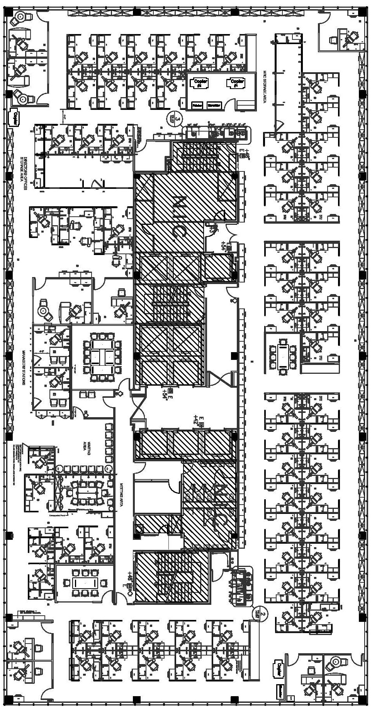
ME
Safer
Room

Multiple Options for Running: Three options access stairways and two lead to a “Safer” Room.
(Tool was provided by Michael Melton, mike.melton@constantassociates.com )

